Table of Contents
Overview 2
1. Cloud Budget (Monthly) 2
2. Actual Spend (Monthly) 3
3. Forecast (Monthly) 3
4. Total Taggable Resources 4
5. Resources Tagged 4
6. Total Cloud Cost 5
7. Shared Cloud Cost 5
8. Recommended Savings 6
9. Implemented Savings 6

Overview

This document outlines the required input fields for the FinOps Governance and Cloud Savings Tracker. It defines the data elements needed to consistently capture and report cloud financial, governance, and optimization information. The tracker is designed to support FinOps, Finance, Engineering, and Leadership stakeholders by consolidating key inputs related to cloud budgeting, actual spend, forecasting, cost allocation, governance maturity, and savings realization into a single, standardized view.

1. Cloud Budget (Monthly)

Definition: Cloud Budget (Monthly) is the manually defined, monthly planned cloud spend captured in Cloudability Budgets and used as the baseline for actual and forecasted spend comparisons. This is approved or planned cloud spend limit for the reporting month, typically defined by Finance, FinOps, or business owners.

Path: Cloudability → Plan → Budgets

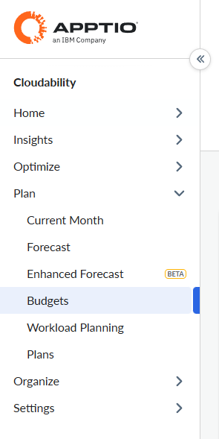

2. Actual Spend (Monthly)

Definition: Actual Spend (Monthly) is the real amount billed by the cloud provider during a specific billing period. It reflects the true invoice cost without spreading commitment costs across time.

Path: Cloudability → Insight → TrueCost Explorer
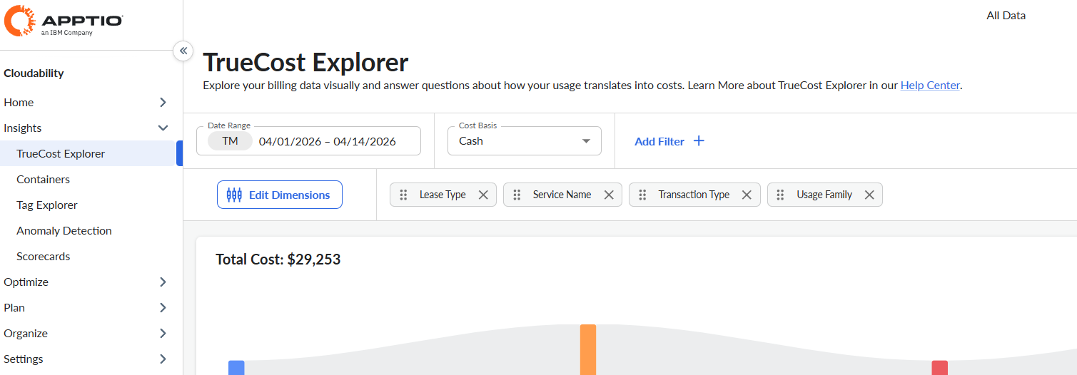

For more information on the available options under the cost basis filter (Cash, Amortized and List) please visit the following IBM documentation.
Cost Dimensions and Metrics

3. Forecast (Monthly)

Definition: Forecast (Monthly) is the system-generated projection of total cloud spend for a selected month, captured from the Cloudability Forecasting module based on historical usage trends and current run-rate.
Path: Cloudability → Plan → Forecasting
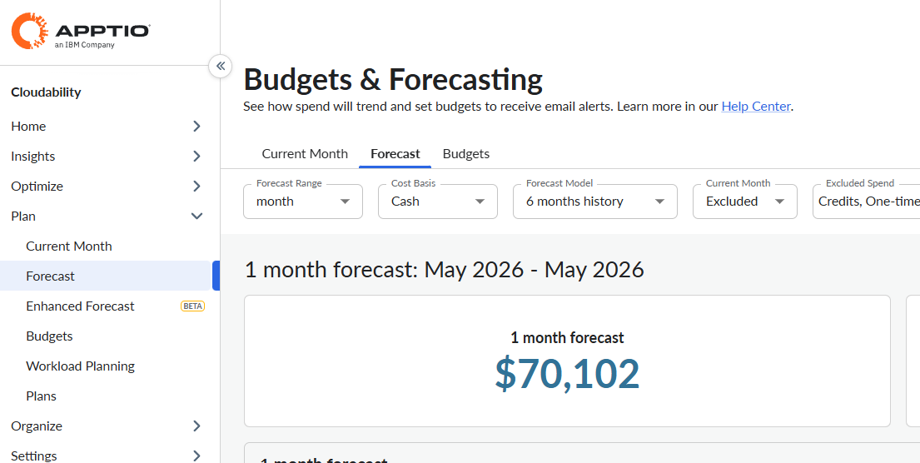

4. Total Taggable Resources

Definition: Total Taggable Resources is the count of all active cloud resources within the selected scope that support tagging, captured from the Cloudability Resource Inventory module. We have capture service wise data point and then calculate total.

Path: Cloudability → Insight → Resource Inventory

Total Taggable Resources = Total Resources

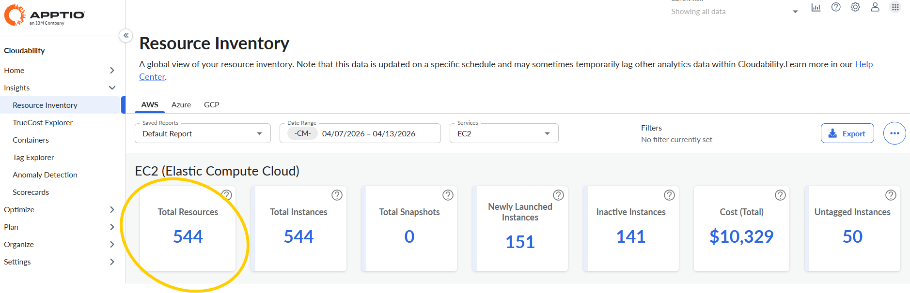
Similarly, we must consider other for services as well.

5. Resources Tagged

Definition: Resources Tagged is the count of active, taggable cloud resources that meet all mandatory tagging requirements within the selected scope, captured from the Cloudability Tagging Governance module.

Path: Cloudability → Insight → Resource Inventory
Resources Tagged = (Total Resources – Untagged Resources)
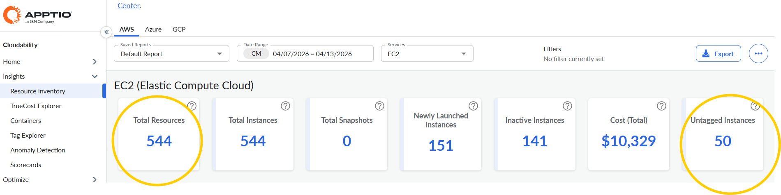
For example: Let’s consider EC2 service
Total resources = 544, Untagged = 50
Resources Tagged = (544-50) = 494
Similarly, we must consider other services as well.

6. Total Cloud Cost

Definition: Total Cloud Cost is the aggregated amortized cloud spend for the selected period and scope, captured from Cloudability Cost Explorer, inclusive of all usage, commitments, discounts, credits, and supporting charges.

Path: Cloudability → Insight → TrueCost Explorer
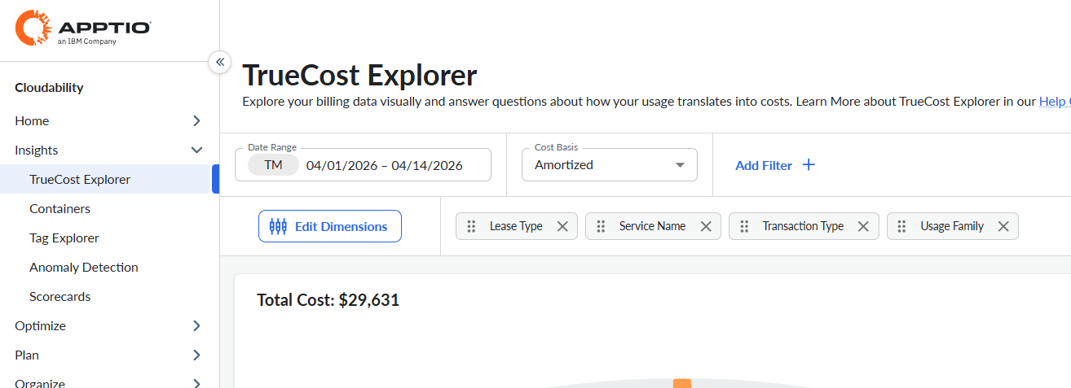

7. Shared Cloud Cost

Definition: Shared Cloud Cost is the portion of total cloud spend that cannot be directly attributed to individual business units or applications, captured from Cloudability’s Cost Allocation module prior to redistribution.

Path: Cloudability → Organise → Cost Sharing & Telemetry

For more information on the shared cost please visit the following IBM documentation.

Sharing Cost in Cloudability

8. Recommended Savings

Definition: Recommended Savings is the estimated potential monthly cost reduction identified from Cloudability optimization recommendations, captured from the Optimize module for a defined scope and period.

Path: Cloudability → Optimize → Dashboard
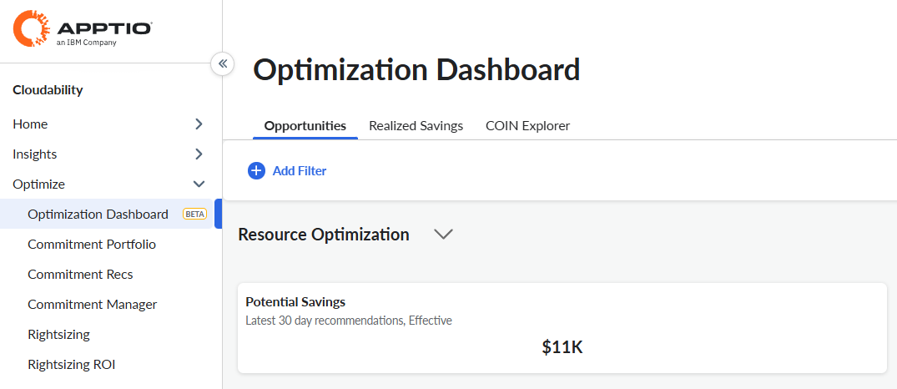

9. Implemented Savings

Definition: Implemented Savings is the confirmed and realized monthly reduction in cloud costs resulting from completed optimization actions, captured from Cloudability’s module.

Path: Cloudability → Optimize → Optimization Dashboard

